# Get Team Names with CTEs (Step 1)

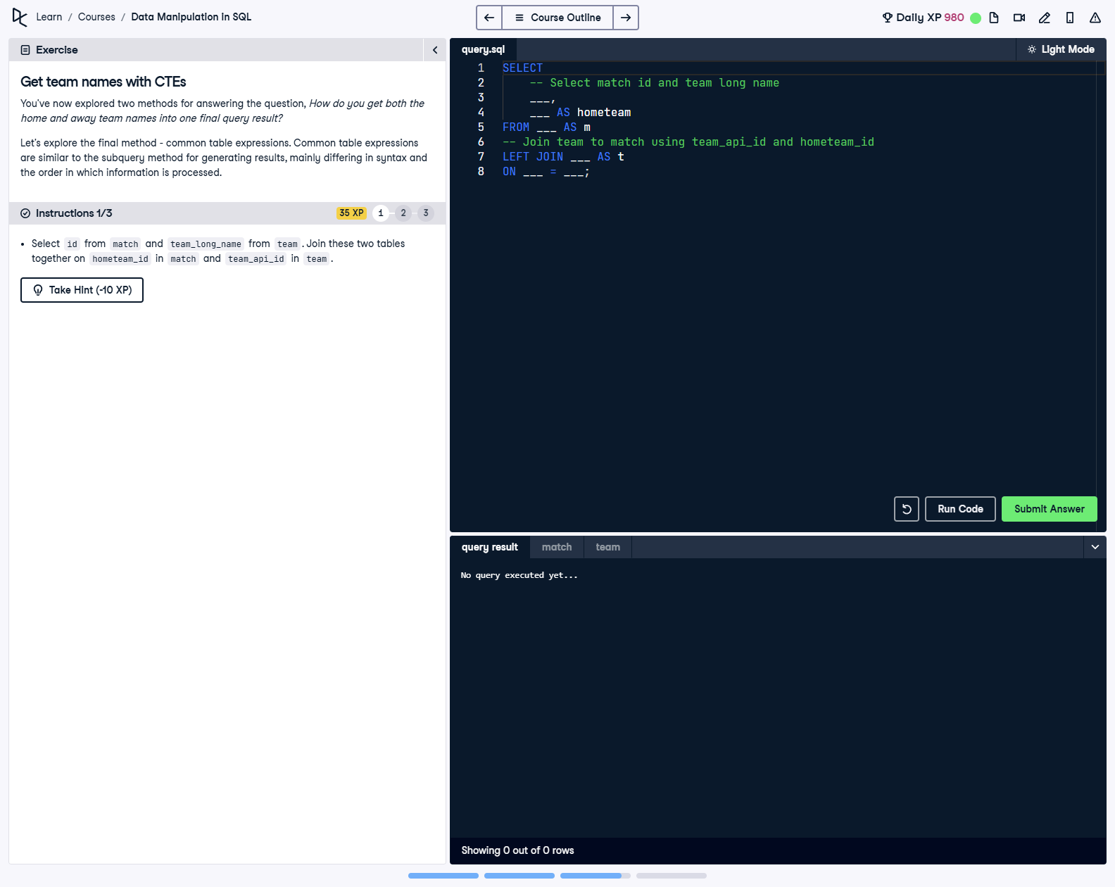

## Question

1. Select id from match and team_long_name from team.  
  
2. Join these two tables together on hometeam_id in match and team_api_id in team.

## Corrected Solution

SELECT  
 -- Select match id and team long name  
 m.id,  
 t.team_long_name AS hometeam  
FROM match AS m  
-- Join team to match using team_api_id and hometeam_id  
LEFT JOIN team AS t  
ON m.hometeam_id = t.team_api_id;

## Explanation

This query retrieves the match ID and the home team name by performing a LEFT JOIN between the match table and the team table. The join is performed on the relationship between hometeam_id in the match table and team_api_id in the team table. The result provides the match ID and the full name of the home team for each match.